MASTER TX :-

MAIN PROGRAM:-

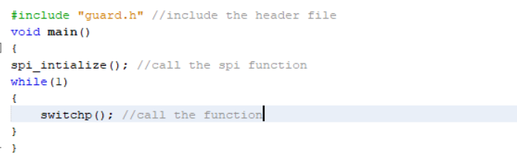

GUARD PROGRAM:-

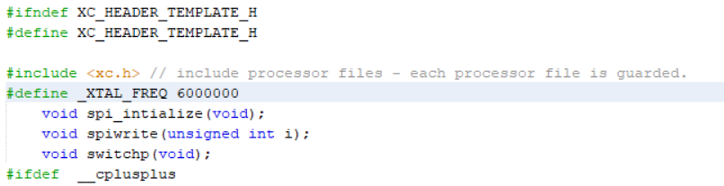

FUNCTION PROGRAM:

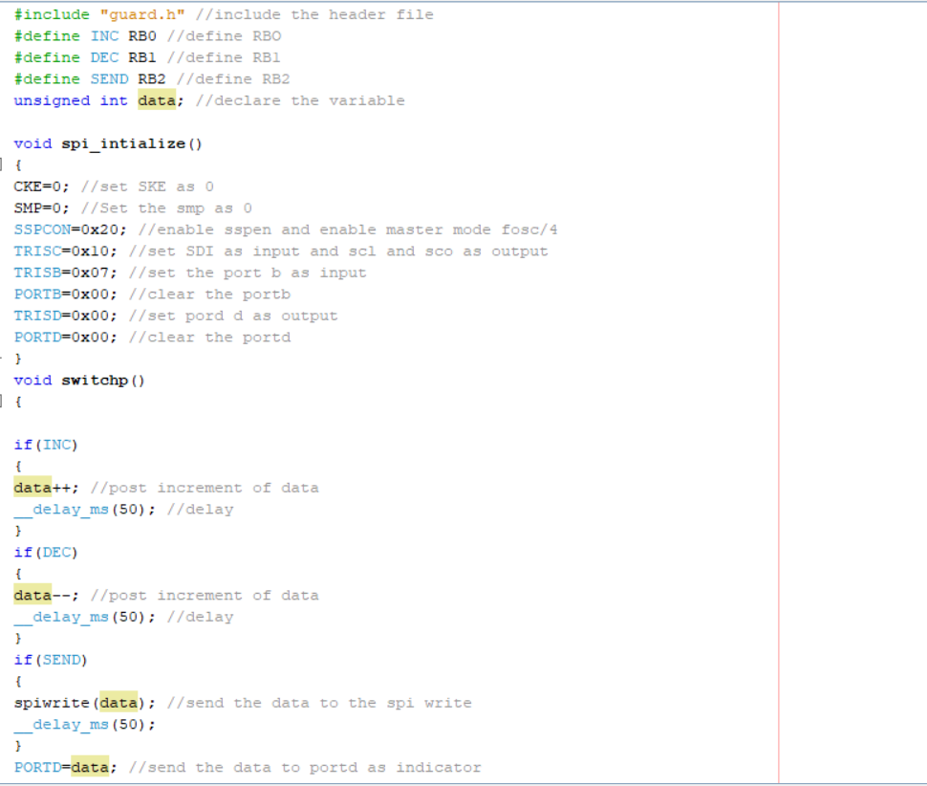

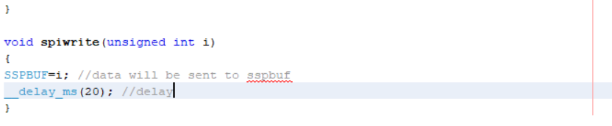

SLAVE RX :-

MAIN PROGRAM:-

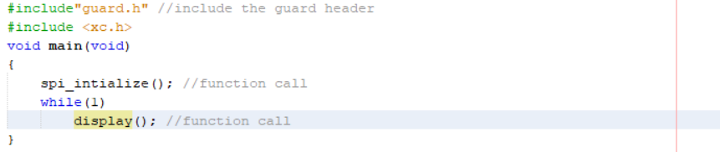

GUARD PROGRAM:-

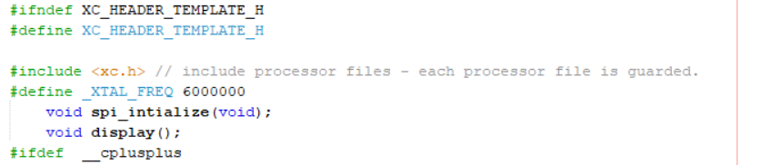

FUNCTION PROGRAM:

